**Database coursework**

**Scenario**

**Requirements**

It was asked for our team to design a new database system for a company called Ace Training to record the details and enrol students to their courses. Student enrolment will be done by students and tutors using an online interface or by a list,  
  
Storing will include personal data of the student (Name, birth date, address, etc), and similar personal details for the tutors and also information regarding the course and if necessary alternating it’s data.

It is also required for records to be created kept or changed according to the performance of the students in the course’s tasks such as quizzes which will in the form of multiple choice, true or false and fill the blanks, while the student’s progress should be visible to both the tutor and pupil.

**Business rules**

After checked tutors are responsible for storing information about their course which will either be available to students, available till a certain deadline or not available at all.

The progress of the pupils will be checked by online assessments and there must be an indicator that will show it.  
  
Students and staff are allowed to be unregistered but not deleted and courses should be able to be deleted after a certain time that are inactive.

Students will not be able to enrol to new courses if their fees are not payed and each student can only complete each course once.

**Business operations**

Ace training is a small independent business that offers lessons for a certain amount of fees. Tutor’s that perform those lectures are responsible for their course in terms of presentation, assessments and general information regarding the teaching procedure.

Online Assessments are to be in the form of quizzes as it is said and are available to be completed with a specific date.

Enrolment is done in three ways describe above and tutors and student’s record are to be kept

Students that are enrolled to the course are responsible for attending and delivering their assessments on time. Furthermore, they are also in charge of taking care their financial deals regarding their fees payment.

Documents and information can be shared across courses if the tutors see appropriate.

**Conceptual design**

**Conceptual Diagram**

tutor

Online assessment results

1:M

1:M

Student progress

Student

course

Online assessments

1:1

1:1

1:1

M:1

1:M

M:M

1:M

**Diagram Script**

|  |  |  |  |
| --- | --- | --- | --- |
| **entity** | **attributes** | **synonyms** | **relationships** |
| student progress | Progress bar  Average knowledge bar  Attendance  Grade  Student name  Student number (FK) | 25%, 50%, 75%, 100%  25%, 50%, 75%, 100%  25%, 50%, 75%, 100%  A, B, C, D, E, F  John, Paul  123,456 | one to one relationship with student, tutor and online assessment results |

|  |  |  |  |
| --- | --- | --- | --- |
| **entity** | **attributes** | **synonyms** | **relationships** |
| student | Student number (PK)  Name  Address  Next of kin name  Next of kin number  Next of kin address  Enrolled for:  Fees paid  DOB  Email  Student visa expiry date  Passport number | 123, 456  John, Paul  123 green lane  John, Paul  1234556789  123 green lane  1 week, 2 weeks  £1000, £500  25/06/99, 20/04/98  [email@email.com](mailto:email@email.com)  22/05/20  1234567 | Many to many with tutor  One to many with course and tutor  One to one with student progress |

|  |  |  |  |
| --- | --- | --- | --- |
| **entity** | **attributes** | **synonyms** | **relationships** |
| course | Course ID (PK)  Resource name  Resource link  Available to students | 1234,5678  Logical design PowerPoint  [www.resources.com](http://www.resources.com)  yes, no | Many to one with student and tutor |

|  |  |  |  |
| --- | --- | --- | --- |
| **entity** | **attributes** | **synonyms** | **relationships** |
| tutor | Tutor ID (PK)  Name  Address  Next of kin name  Next of kin number  Next of kin address  Office number  DOB  Email  NIN | 12345  John, Paul  123 green lane  John, Paul  123456789  123 green lane  1, 2  20/04/98  [email@email.com](mailto:email@email.com)  PE 604040 | One to many with course assessments and assessment results  Many to many with student |

|  |  |  |  |
| --- | --- | --- | --- |
| **entity** | **attributes** | **synonyms** | **relationships** |
| Online assessments | Assessment number (PK)  Question number  Question  Recorded answer | 1, 2  1, 2  What is your name?  john | Many to one with student and tutor |

|  |  |  |  |
| --- | --- | --- | --- |
| **entity** | **attributes** | **synonyms** | **relationships** |
| Online assessment results | Assessment number (FK)  Percentage  Grade  Student name | 1, 2  25%, 50%, 75%, 100%  A, B, C, D, E, F  john | One to one with student progress  Many to one with tutor |

**Logical design**

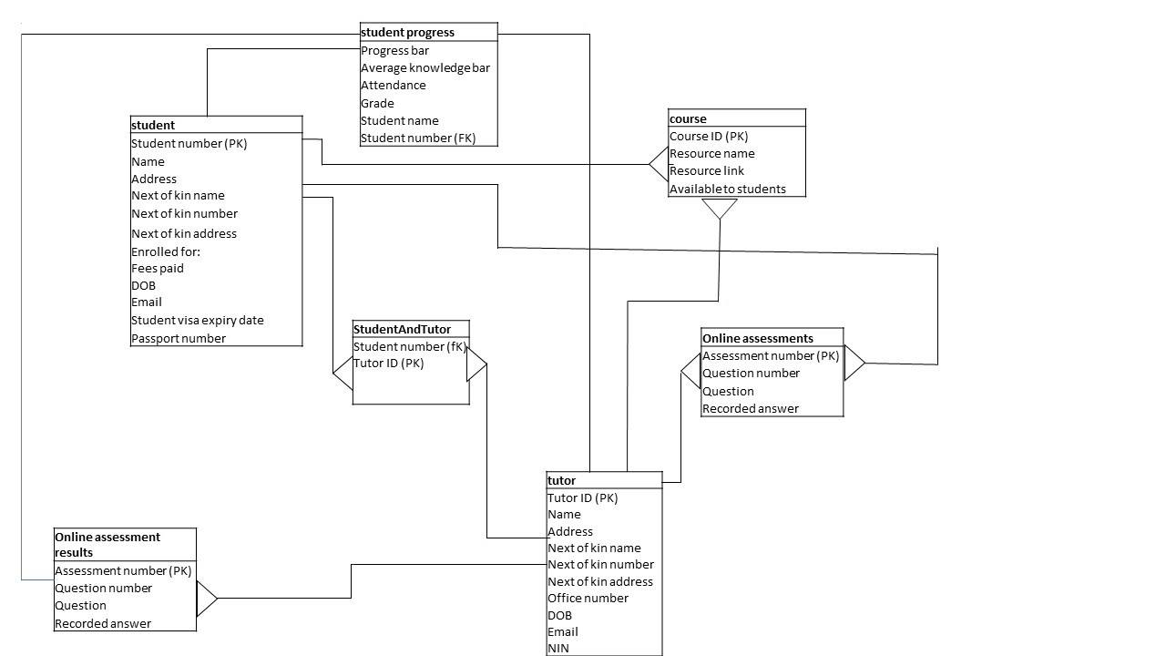

**Normalisation**

**Cumulative Design**

STUDENT (student number, name, address, next of kin name, next of kin number, next of kin address, enrolled for, fees paid, DOB, email address, student visa expiry date, passport number)

TUTOR (tutor ID, name, address, next of kin name, next of kin number, next of kin address, office number, extension number, DOB, email, NIN)

COURSE (course ID, resource name, resource link, available to students?)

ONLINE ASSESMENTS (assessment number, question number, question, recorded answer)

ONLINE ASSESMENT RESULTS (assessment number, percentage, grade, student name)

STUDENT PROGRESS (student number, grade, student name, attendance, average knowledge bar, progress bar)

**UNF**

STUDENT

|  |  |  |  |  |  |  |  |  |  |  |  |
| --- | --- | --- | --- | --- | --- | --- | --- | --- | --- | --- | --- |
| Student number | name | address | next of kin name | Next of kin number | next of kin address | Enrolled for | Fees paid | DOB | Email address | Student visa expiry date | Passport number |

TUTOR

|  |  |  |  |  |  |  |  |  |  |  |
| --- | --- | --- | --- | --- | --- | --- | --- | --- | --- | --- |
| Tutor ID | name | address | Next of kin name | Next of kin number | Next of kin address | Office number | Extension number | DOB | Email | NIN |

|  |  |  |  |
| --- | --- | --- | --- |
| Course ID | Resource name | Resource link | Available to students? |

COURSE

ONLINE ASSESMENTS

|  |  |  |  |
| --- | --- | --- | --- |
| assessment number | Question number | question | Recorded answer |

ONLINE ASSESMENT RESULTS

|  |  |  |  |
| --- | --- | --- | --- |
| Assessment number | percentage | grade | Student name |

STUDENT PROGRESS

|  |  |  |  |  |  |
| --- | --- | --- | --- | --- | --- |
| Progress bar | Average knowledge bar | attendance | grade | Student name | Student number |

|  |  |  |  |  |  |  |  |  |  |  |  |
| --- | --- | --- | --- | --- | --- | --- | --- | --- | --- | --- | --- |
| Student number | name | address | next of kin name | Next of kin number | next of kin address | Enrolled for | Fees paid | DOB | Email address | Student visa expiry date | Passport number |

**1NF**

STUDENT

|  |  |  |  |  |  |  |  |  |
| --- | --- | --- | --- | --- | --- | --- | --- | --- |
| Student number | name | address | Enrolled for | Fees paid | DOB | Email address | Student visa expiry date | Passport number |

|  |  |  |  |
| --- | --- | --- | --- |
| Student number | Next of kin name | Next of kin number | Next of kin address |

TUTOR

|  |  |  |  |  |  |  |  |  |  |  |
| --- | --- | --- | --- | --- | --- | --- | --- | --- | --- | --- |
| Tutor ID | name | address | Next of kin name | Next of kin number | Next of kin address | Office number | Extension number | DOB | Email | NIN |

|  |  |  |  |  |  |  |  |
| --- | --- | --- | --- | --- | --- | --- | --- |
| Tutor ID | name | address | Office number | Extension number | DOB | Email | NIN |

|  |  |  |  |
| --- | --- | --- | --- |
| Tutor ID | next of kin name | Next of kin number | Next of kin address |

Course, online assessments, online assessment results and student progress already 1NF

**2NF**

|  |  |  |  |
| --- | --- | --- | --- |
| Tutor ID | next of kin name | Next of kin number | Next of kin address |

|  |  |  |  |
| --- | --- | --- | --- |
| Student number | Next of kin name | Next of kin number | Next of kin address |

|  |  |  |
| --- | --- | --- |
| next of kin name | Next of kin number | Next of kin address |

(next of kin used as a link table between student and tutor as many to many relationships are not allowed)

**3NF**

All tables already 3NF.

**Implementation**

**Field attribute sizes**

STUDENT- student number: 6, name: 30, address: 40, enrolled for: 15, fees paid: 3, DOB: 12, email: 40, student visa expiry date: 12, passport number: 10

NEXT OF KIN: student number: 6, tutor id: 6, next of kin name: 30, next of kin number: 12, next of kin address: 40

TUTOR- tutor ID: 6, name: 30, address: 40, office number: 10, extension number: 10, DOB: 12, email: 40, NIN: 8

COURSE- course ID: 6, resource name: 30, resource link: 40, available to students?: 3

ONLINE ASSESSMENT- assessment number: 3, question number: 3, question: 3, recorded answer: 200

ONLINE ASSESSMENT RESULTS- assessment number: 3, percentage: 3, grade: 1, student name: 30

STUDENT PROGRESS- student number: 6, grade: 1, student name: 30, attendance: 3, average knowledge bar: 3, progress bar: 3

**SQL implementation**

CREATE DATABASE UniversityDatabase

CREATE TABLE student

(

StudentNumber auto_increment,

Name varchar (30) not null,

Address varchar (40),

EnrolledFor varchar (15) not null,

FeesPaid bit not null,

DOB date not null,

Email varchar (40),

StudentVisaExpiryDate date not null,

Passport number varchar (10),

Primary key (StudentNumber)

);

CREATE TABLE NextOfKin

(

NextOfKinName varchar (30) not null,

NextOfKinNumber varchar (30) not null,

NextOfKinAddress varchar (40),

Foreign key (StudentNumber) references student (StudentNumber),

Foreign key (tutorID) references tutor (tutorID)

);

CREATE TABLE tutor

(

tutorID auto_increment,

name varchar (30) not null,

address varchar (40),

OfficeNumber int,

ExtensionNumber int,

DOB date not null,

Email varchar (40),

NIN varchar (8),

Primary key (tutorID)

);

CREATE TABLE course

(

CourseID auto_increment,

ResourceName varchar (30) not null,

ResourceLink varchar (40) not null,

AvailableToStudents bit not null,

Primary key (coursID)

);

CREATE TABLE OnlineAssessment

(

AssessmentNumber auto_increment,

QuestionNumber int not null,

Question varchar (100) not null,

RecordedAnswer varchar (500),

Primary key (AssessmentNumber)

);

CREATE TABLE OnlineAssessmentResults

(

Percentage decimal (3,2) not null,

Grade varchar (1) not null,

Foreign key (AssessmentNumber) references OnlineAssessment (AssessmentNumber),

Foreign key (StudentNumber) references student (StudentNumber)

);

CREATE TABLE StudentProgress

(

Grade varchar (1) not null,

Attendance decimal (3,2) not null,

AverageKnowledgeBar decimal (3,2) not null,

ProgressBar decimal (3,2) not null,

Foreign key (StudentNumber) references student (StudentNumber)

);

**Security**

SET PASSWORD FOR ‘root’@’0.0.0.0’=

PASSWORD (‘Password123!’);

CREATE USER ‘administrator’@’localhost’ IDENTIFIED BY ‘mypass1’

CREATE USER ‘tutor’@’localhost’ IDENTIFIED BY ‘mypass2’

CREATE USER ‘student’@’localhost’ IDENTIFIED BY ‘mypass3’

GRANT ALL ON UniversityDatabase.* To ‘administrator’@’localhost’;

GRANT ALTER (RecordedAnswer).* ON UiversityDatabase.OnlineAssessment To ‘studnet’@’localhost’;

GRANT SELECT ON UniversityDatabase.* To ‘student’@’localhost’;

GRANT SELECT ON UniversityDatabase.* To ‘tutor’@’localhost’;

GRANT SELECT, INSET, UPDATE ON (UniversityDatabase.OnlineAssessmnet, UniversityDatabase.OnlineAssessmnetResults, UniversityDatabase.course, UniversityDatabase.StudentProgress)* To ‘tutor’@’localhost’;

**Contingencies and Testing**

The database and the data stored in it should be protected from contingencies such as hardware failure but also from physical damage to the hardware.

As it is not guaranteed that nothing will happen to the hardware it will be backed up to the universities network. The main reason for this is the university will retain ownership to the data. Also, it is easy to maintain, however it would require a specialist to implement. Once installed it can be managed in house.

Another option would have been to back it up to tape, but this is outdated and can’t be a shared resource. The tapes could also be damaged like the original hardware. Also, tape cannot be repurposed.

The reasons for storing it on site are: to reduce costs from implementing the backup as well as possible monthly costs, possible lack of ownership of data and backups could be slower. Also, if it is not private you don’t really know if the data is fully secure. You do not know where your data is so if it is in another country the laws regarding protection of the data may differ.

The tests needed to be done are: Data validity testing, Data Integrity testing, Performance related to data base, Testing of Procedure, triggers and functions. To do this, test data should be inputted to see if it is accepted. The functionality of the database should also be tested. Another thing to be tested is if all the users can perform the functions needed and also that do not have any more functionality than they need to enforce more security.

**Graphical user interface design**

**Interface structure diagram**

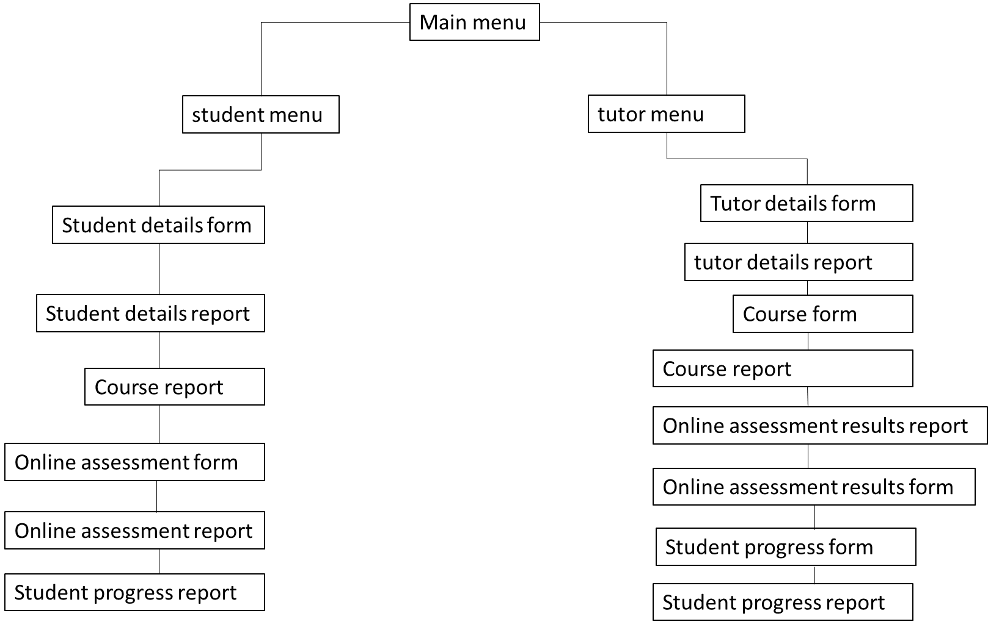

**Layout concept**

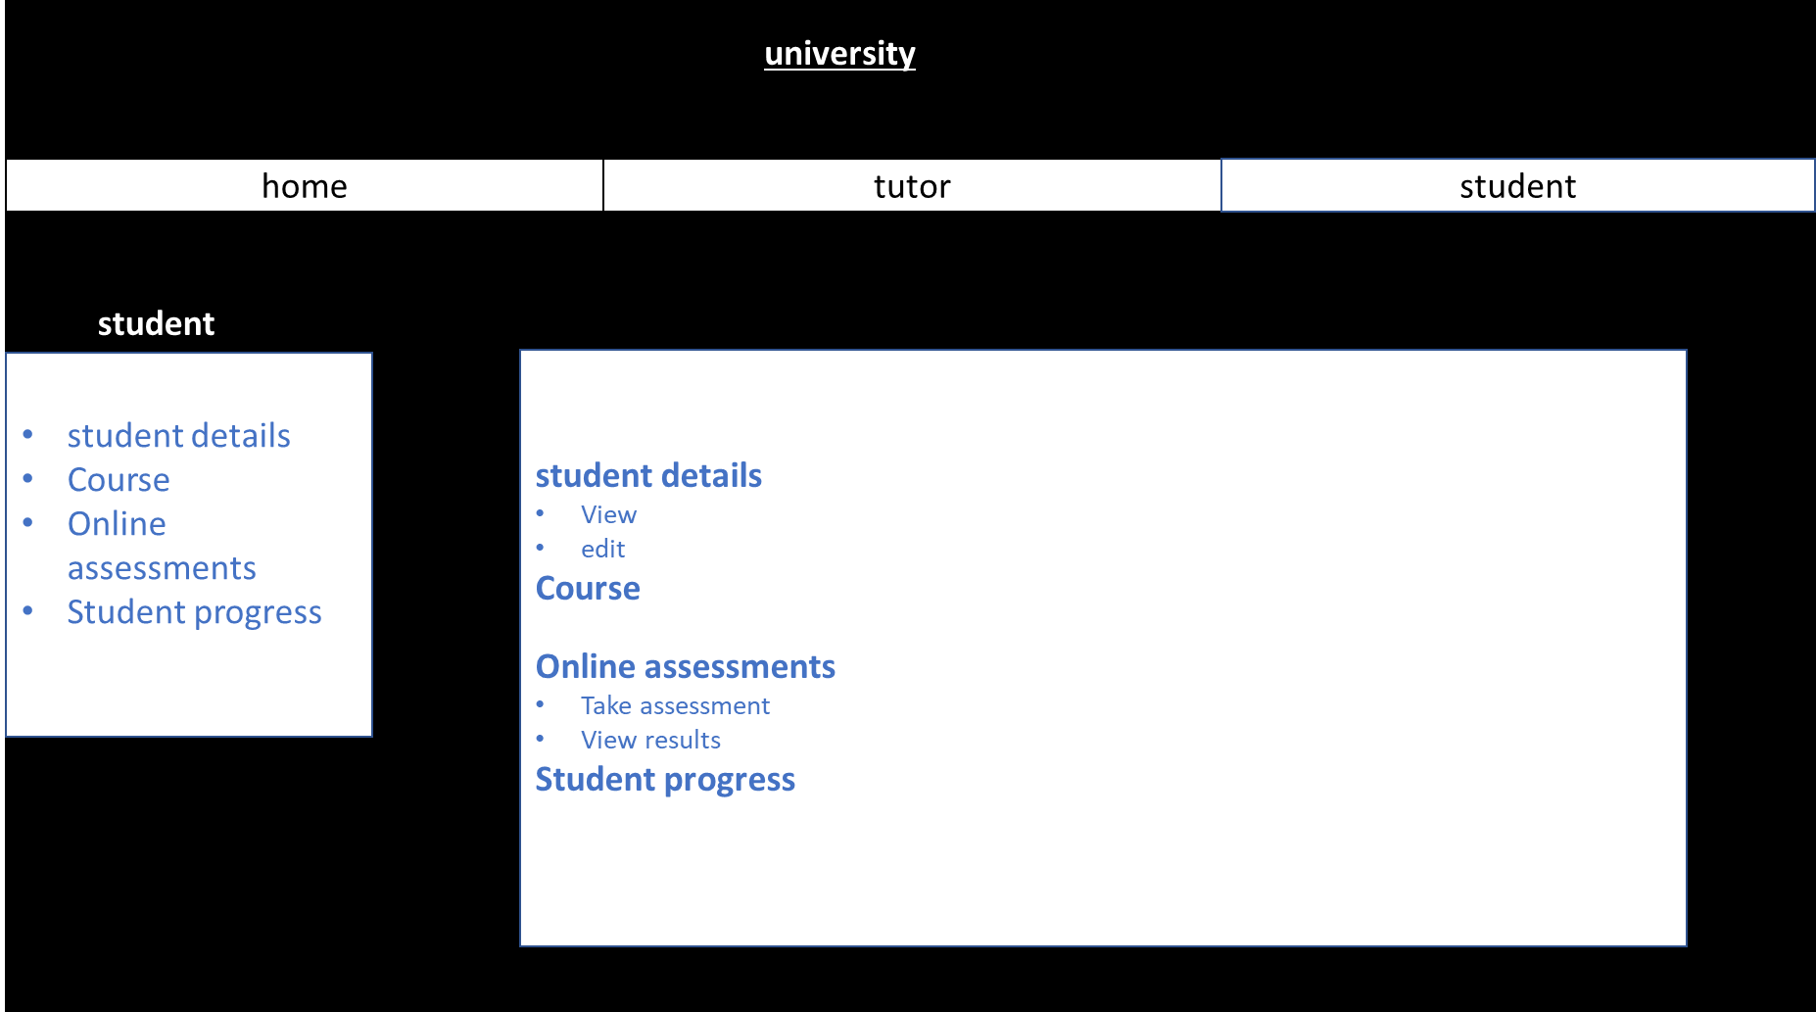

**Input form concept**

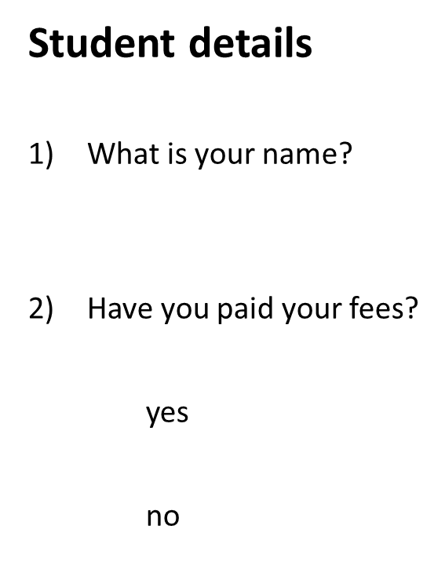



**References**

<https://www.studytonight.com/dbms/database-normalization.php> [accessed 20/02/19]

<http://www.databasedev.co.uk/user_interface_design.html> [accessed 10/03/19]

<https://www.360logica.com/blog/what-is-database-testing/> [accessed 16/03/19]